Yaha tk pahuche means logistic regression ka logic bn gaya hoga , and trainging testing ho gayi hogi model ki.
Next: Computational graph, [Neural networks in sb me jarurat pdegi.]
Imp: rules ki book hath me rkhni pdegi.[derivatives k rules , kanthasth.]
Now let se ek function he
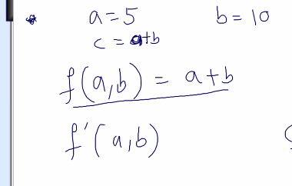
Iska computational graph esa bnage
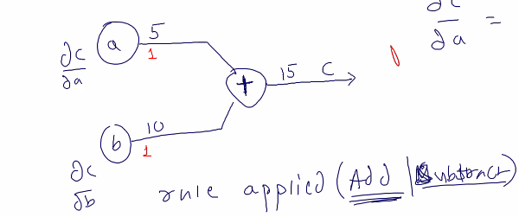
Ab c 2 ways me change ho skta he, a change ho tb , b change ho tb , ya dono change ho tb.
C wrt a = dc/da wrt b dc/db
Ab dc/da=1 aya, and dc/db bhi 1 aaya.
Iska kya mtlb?
means a=5 ko mene change kiya like add 3 tb c me kya change aayega?
A=5+3=8 to c=a+b= 8+10 =18.
Isko direct kese nikale?
C= a*dc/da +c = 3*1 +15= 3+15 = 18 {dc/da=1 aaya tha, a= what ever new value added to a.}

Next example:
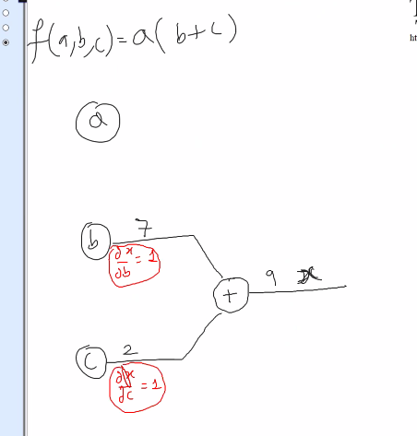
Part 10 thoda or bcha
Part11 me derivatives and forward and backward propagation he
Part 12 me page no. 5 se cpp k topics

